**Vidyashree**

**1NT19IS185**

**Execrcise-3: Map Reduce (Programs)**

Use the Hadoop framework to write a custom MapReduce program to perform word count

operation on a custom data set .

**Java Code:-**

package vidyashree;

import java.io.IOException;

import java.util.*;

import org.apache.hadoop.fs.Path;

import org.apache.hadoop.io.IntWritable;

import org.apache.hadoop.io.LongWritable;

import org.apache.hadoop.io.Text;

import org.apache.hadoop.mapred.FileInputFormat;

import org.apache.hadoop.mapred.FileOutputFormat;

import org.apache.hadoop.mapred.JobClient;

import org.apache.hadoop.mapred.JobConf;

import org.apache.hadoop.mapred.MapReduceBase;

import org.apache.hadoop.mapred.Mapper;

import org.apache.hadoop.mapred.OutputCollector;

import org.apache.hadoop.mapred.Reducer;

import org.apache.hadoop.mapred.Reporter;

import org.apache.hadoop.mapred.TextOutputFormat;

import org.apache.hadoop.mapred.TextInputFormat;

public class WordCount {

public static class Map extends MapReduceBase implements

Mapper<LongWritable, Text, Text, IntWritable> {

private final static IntWritable one = new IntWritable(1);

private Text word = new Text();

public void map(LongWritable key, Text value, OutputCollector<Text, IntWritable>

output, Reporter reporter) throws IOException {

String line = value.toString();

StringTokenizer tokenizer = new StringTokenizer(line);

while (tokenizer.hasMoreTokens()) {

word.set(tokenizer.nextToken());

output.collect(word, one);

}

}

}

public static class Reduce extends MapReduceBase implements

Reducer<Text, IntWritable, Text, IntWritable> {

public void reduce(Text key, Iterator<IntWritable> values,

OutputCollector<Text, IntWritable> output, Reporter reporter)

throws IOException {

int sum = 0;

while (values.hasNext()) {

sum += values.next().get();

}

output.collect(key, new IntWritable(sum));

}

}

public static void main(String[] args) throws Exception {

JobConf conf = new JobConf(WordCount.class);

conf.setJobName("wordcount");

conf.setOutputKeyClass(Text.class);

conf.setOutputValueClass(IntWritable.class);

conf.setMapperClass(Map.class);

conf.setCombinerClass(Reduce.class);

conf.setReducerClass(Reduce.class);

conf.setInputFormat(TextInputFormat.class);

conf.setOutputFormat(TextOutputFormat.class);

FileInputFormat.setInputPaths(conf, new Path(args[0]));

FileOutputFormat.setOutputPath(conf, new Path(args[1]));

JobClient.runJob(conf);

}

}

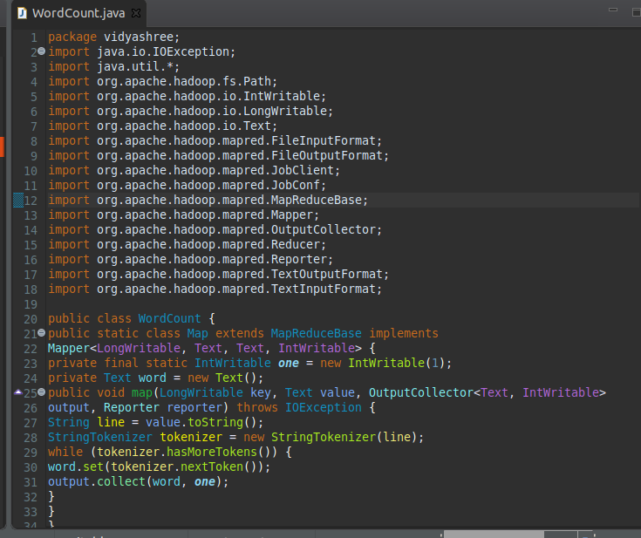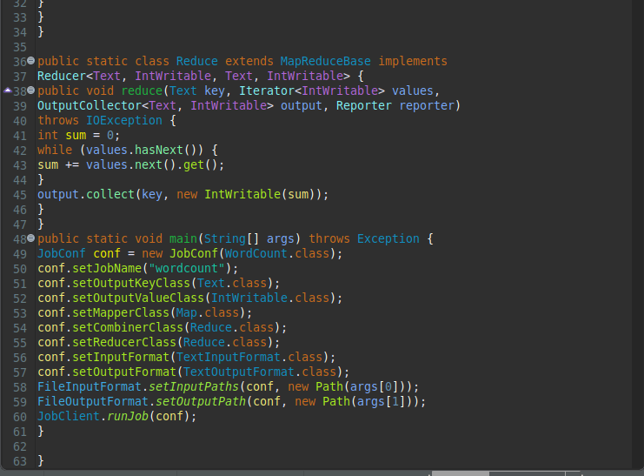

hdoop@admin1-HP-280-G4-MT-Business-PC:~$ cd $HADOOP_HOME/sbin



hdoop@admin1-HP-280-G4-MT-Business-PC:~/hadoop-3.2.1/sbin$ start-all.sh

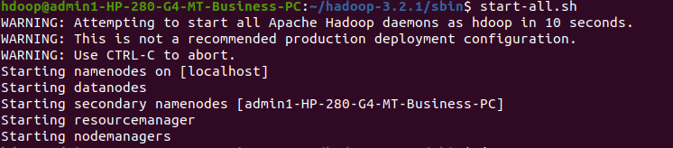

hdoop@admin1-HP-280-G4-MT-Business-PC:~/hadoop-3.2.1/sbin$ jps

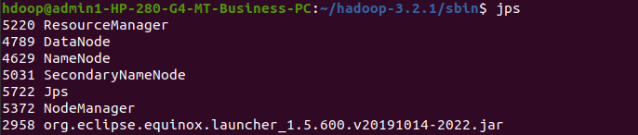

hdoop@admin1-HP-280-G4-MT-Business-PC:~/hadoop-3.2.1/sbin$ hdfs fsck /

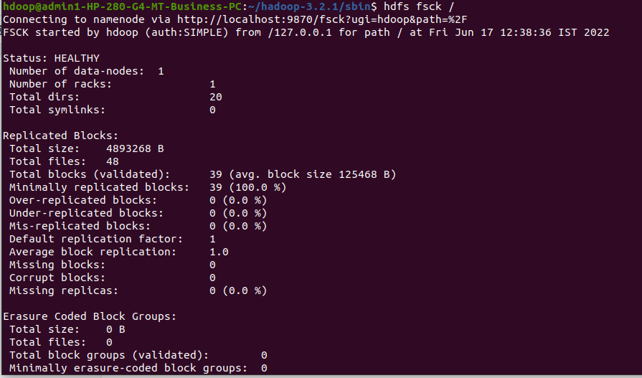

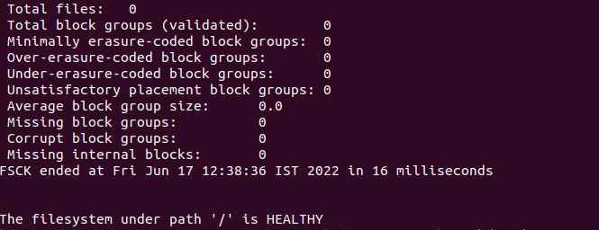

hdoop@admin1-HP-280-G4-MT-Business-PC:~/hadoop-3.2.1/sbin$ hdfs dfs -ls /

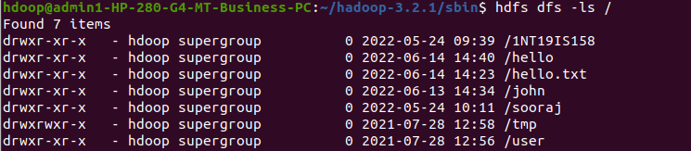

hdoop@admin1-HP-280-G4-MT-Business-PC:~/hadoop-3.2.1/sbin$ hdfs dfs -mkdir -p /vidya

hdoop@admin1-HP-280-G4-MT-Business-PC:~/hadoop-3.2.1/sbin$ hdfs dfs -touchz /vidya/first.txt



hdoop@admin1-HP-280-G4-MT-Business-PC:~/hadoop-3.2.1/sbin$ hdfs dfs -appendToFile - /vidya/text.txt



hdoop@admin1-HP-280-G4-MT-Business-PC:~/hadoop-3.2.1/sbin$ hadoop jar /home/hdoop/Desktop/vidya.jar /vidya /out

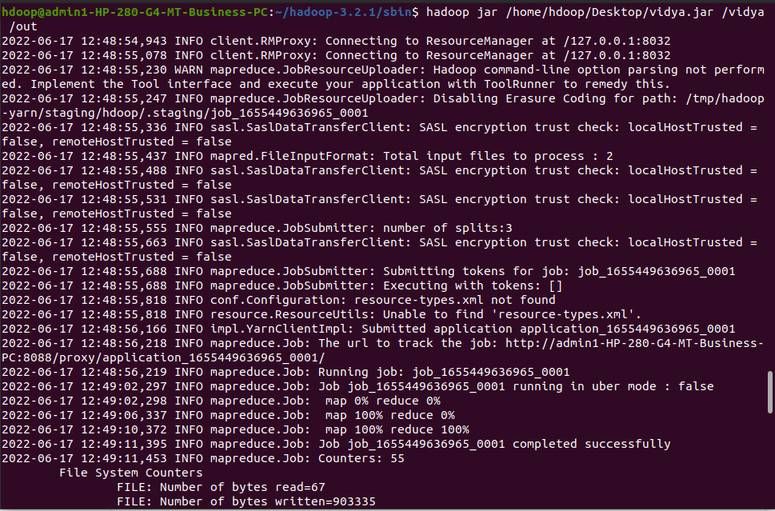

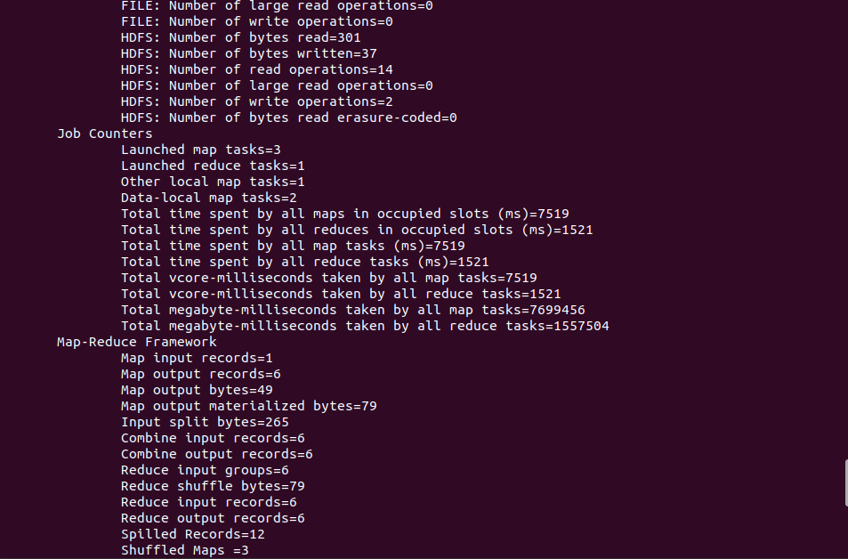

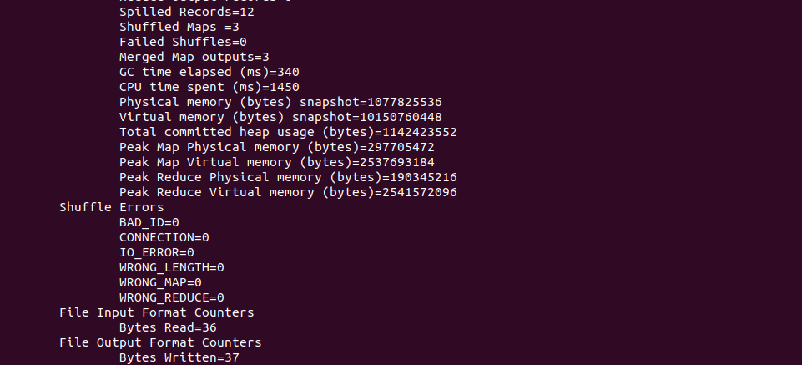

hdoop@admin1-HP-280-G4-MT-Business-PC:~/hadoop-3.2.1/sbin$ hadoop jar /home/hdoop/Desktop/vidya.jar /vidya /out

